**Applecross Senior High School**



**Western Australian Certificate of Education**

**Semester One Examination, 2018**

**Question/Answer Booklet**

|  |  |  |  |
| --- | --- | --- | --- |
|  | **Total** | **Result** | **_____%** |
| **Section One** | **52** |  |
| **Section Two** | **98** |  |
| **Total** | **150** |  |

**MATHEMATICS**

**METHODS**

**UNIT 1**

**Section One:**

**Calculator- free**

**Student’s Name**: **_______________________________________**

**As shown on your exam timetable**

**Student’s Teacher Mr Bradbury Mr Nesa**

(**Circle your teacher’s name**.)

**Ms Thamrin**

**Time allowed for this section**

Reading time before commencing work: five minutes

Working time for this section: fifty minutes

**Materials required/recommended for this section**

***To be provided by the supervisor***

This question /Answer Booklet

Formula Sheet

***To be provided by the candidate***

Standard Items: pens (blue/black preferred), pencils (including coloured), sharpener,

correction fluid/tape, eraser, ruler, highlighters.

Special items: nil.

**Important note to candidates**

No other items may be taken into the examination room. It is **your** responsibility to ensure

that you do not have any unauthorized notes or other items of a non-personal nature in the

examination room. If you have any unauthorized material with you, hand it to the supervisor

**before** reading any further.

|  |  |  |  |  |  |  |
| --- | --- | --- | --- | --- | --- | --- |
| Section | Number of questions available | Number of questions to be answered | | Working time (minutes) | Marks available | Percentage of exam |
| Section One:  Calculator-free | 8 | 8 | | 50 | 52 | 35 |
| Section Two:  Calculator-assumed | 13 | 13 | | 100 | 98 | 65 |
|  | | | **Total** | | 150 | 100 |

## Instructions to candidates

1. The rules for the conduct of examinations are detailed in the *School Examination Rules* provided with your exam timetable.Sitting this examination implies that you agree to abide by these rules.
2. Write your answers in this Question/Answer Booklet.
3. You must be careful to confine your responses to the specific questions asked and to follow any instructions that are specific to a particular question.
4. Spare pages are included at the end of this booklet. They can be used for planning your responses and/or as additional space if required to continue an answer.

* Planning: If you use the spare pages for planning, indicate this clearly at the top of the page.
* Continuing an answer: If you need to use the space to continue an answer, indicate in the original answer space where the answer is continued, i.e. give the page number. Fill in the number of the question(s) that you are continuing to answer at the top of the page.

1. **Show all your working clearly**. Your working should be in sufficient detail to allow your answers to be checked readily and for marks to be awarded for reasoning. Incorrect answers given without supporting reasoning cannot be allocated any marks. For any question or part question worth more than two marks, valid working or justification is required to receive full marks. If you repeat an answer to any question, ensure that you cancel the answer you do not wish to have marked.
2. It is recommended that you **do not use pencil**, except in diagrams.
3. The formula sheet and your notes are **not to be handed** in with your Question/Answer Booklet.

Section One: Calculator-free 35% (52 Marks)

This section has**eight (****8)** questions. Answer **all** questions. Write your answers in the spaces provided.

Working time: 50 minutes.

Question 1 (5 marks)

(a) Solve $5\left(2t+1\right)-3\left(t-4\right)=0$ for $t$. (2 marks)

(b) Solve $\begin{matrix}7 \\ \overline{a-5}\end{matrix}-\begin{matrix}3 \\ \overline{4a}\end{matrix}=0$ for $a$. (3 marks)

Question 2 (5 marks)

Solve the following equations.

(a) $6x^{2}=3x$. (2 marks)

(b) $x\left(x+2\right)=24$. (3 marks)

Question 3 (6 marks)

A function is defined by $f\left(x\right)=\sqrt{3x}$.

(a) Calculate $f(12)$. (1 mark)

(b) State the domain and range of $f(x)$. (2 marks)

(c) Sketch the graph of $y=f(x)$ on the axes below. (3 marks)

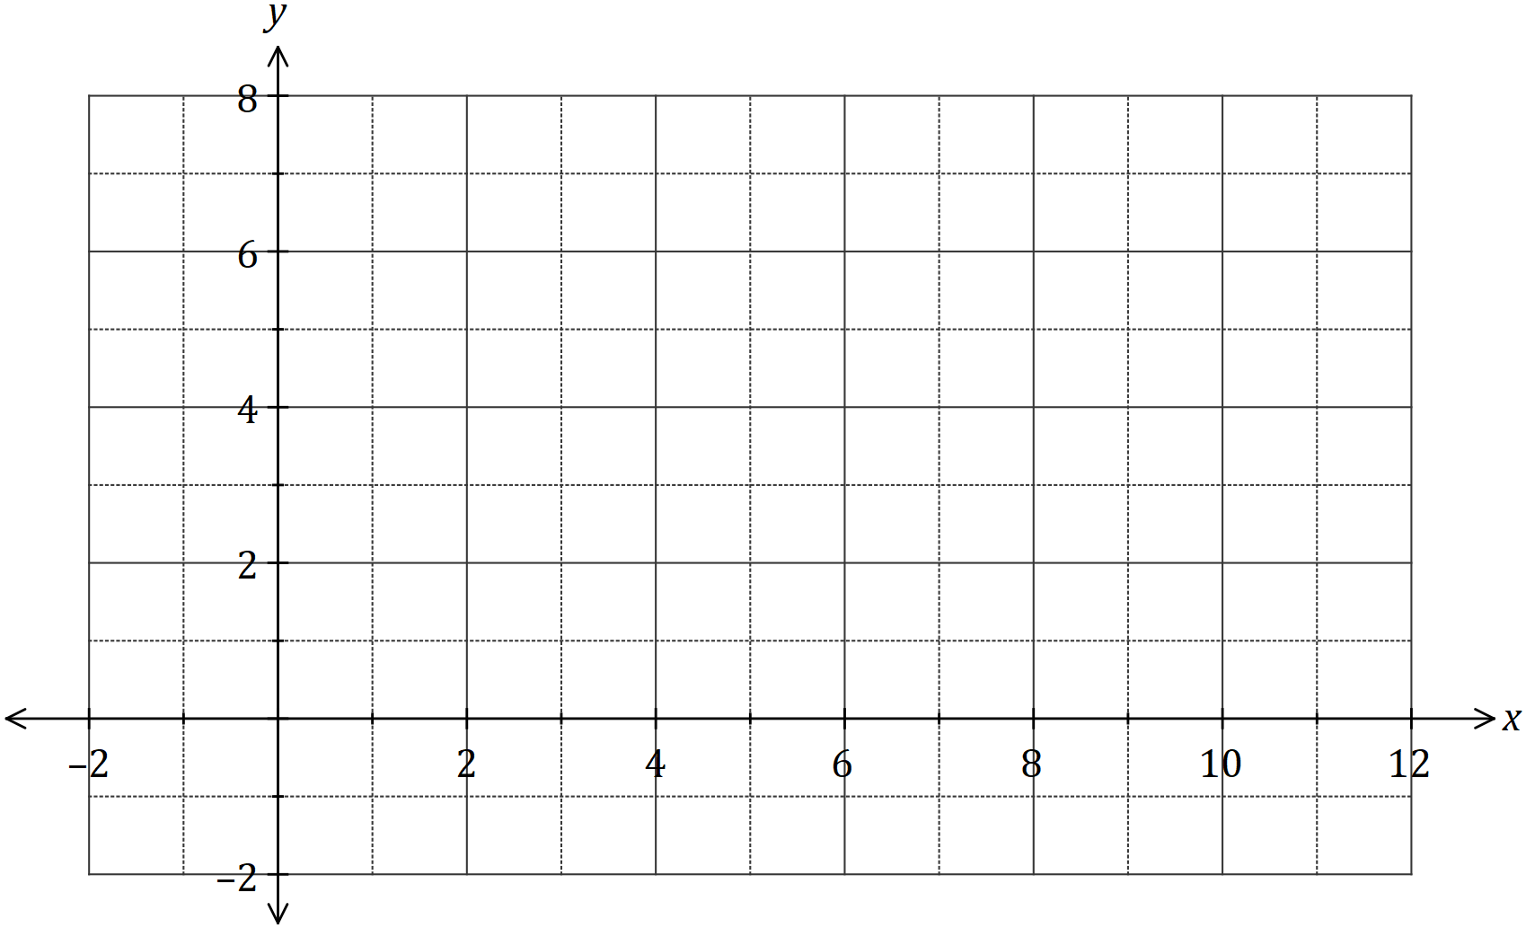

Question 4 (5 marks)

The graph of the line $L_{1}$ is shown below.

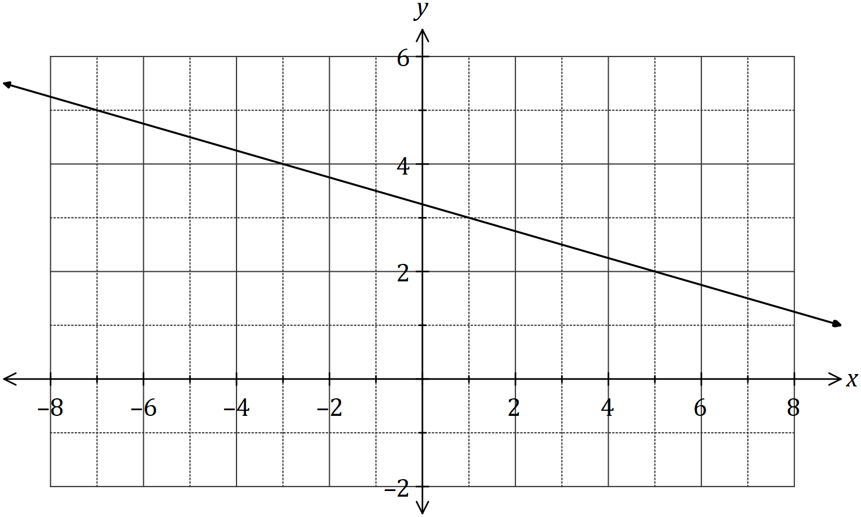

(a) Determine the equation of $L_{1}$. (2 marks)

Two points are located at $A(-10, 5)$ and $B(6, 29)$.

(b) Line $L_{2}$ is perpendicular to $L_{1}$ and passes through the mid-point of $A$ and $B$. Determine the equation of $L_{2}$. (3 marks)

Question 5 (6 marks)

(a) Expand and simplify $(x+2)(2x-5)(x-2)$. (2 marks)

(b) One solution to the equation $x^{3}+36=5x^{2}+12x$ is $x=2$. Determine all other solutions.

(4 marks)

Question 6 (9 marks)

(a) Solve the equation $\sqrt{3}\tan{(x)}-3=0$ for $0≤x≤2π$. (3 marks)

(b) A function has a period of $k$ and is defined by $f\left(x\right)=4\cos{(2x)}$.

(i) State the value of $k$. (1 mark)

(ii) State the amplitude of $f(x)$. (1 mark)

(iii) Sketch the graph of $y=f(x)$ over the domain $-k≤x≤k$. (4 marks)

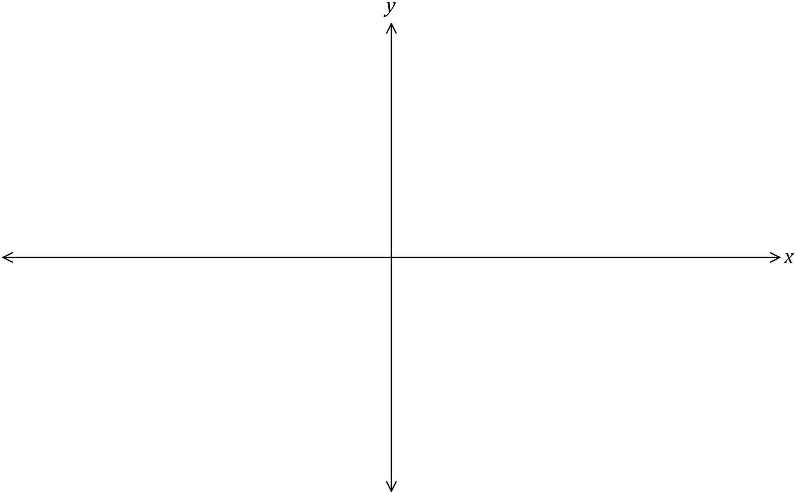

Question 7 (9 marks)

(a) Determine the **coordinates** of the $y$-axis intercept of the line $3x+5y-11=0$. (2 marks)

(b) A quadratic function is given by $y=(x-1)(x+4)$. For the graph of this function, determine

(i) the coordinates of the $y$-axis intercept. (1 mark)

(ii) the coordinates of the zeros (ie the $x$-axis intercepts). (2 marks)

(iii) the equation of the axes of symmetry. (2 marks)

(iv) the coordinates of the turning point. (2 marks)

Question 8 (7 marks)

(a) The graph of the relation $y^{2}=x$ passes through the points $\left(16,a\right)$ and $(b, -5)$. Determine the values of $a$ and $b$. (3 marks)

(b) Another relation is defined by ${\left(x-1\right)}^{2}+{\left(y+2\right)}^{2}=4$.

(i) Sketch the graph of this relation on the axes below. (3 marks)

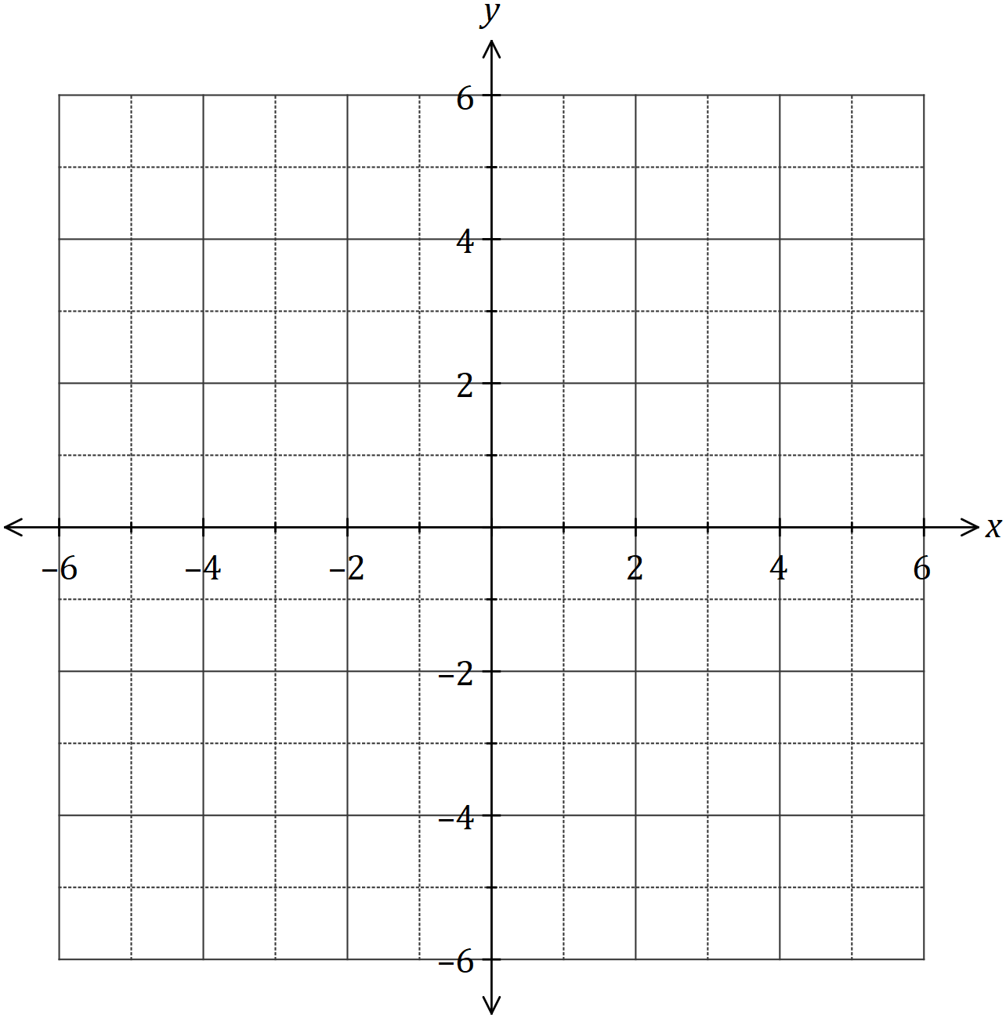

(ii) What feature of the graph indicates that a relation rather than a function is shown?

(1 mark)

**Additional working space.**

**Question Number _________**

**Additional working space.**

**Question Number: _________**